Privacy Protection and Intrusion Avoidance for Cloudlet-based Medical Data Sharing

#### PRIVACY PROTECTION AND INTRUSION AVOIDANCE FOR CLOUDLET-BASED MEDICAL DATA SHARING

#### A Major Project Report Submitted for partial fulfillment for the award of the Degree of Bachelor of Technology

In

**Computer Science and Engineering**

By

**M.BHARGAVI 19C41A05D3**

**P. RACHANA 19C41A05E1**

K. ABHISHEK 19C41A05C1

**J. VAMSHI 19C41A05D2**

Under the Guidance of

**Dr. P. PUNNAM CHANDER**

**(**Associate Professor)



**Department of Computer Science and Engineering**

##### JAYAMUKHI INSTITUTE OF TECHNOLOGICAL SCIENCES (AUTONOMOUS)

**NARSAMPET,WARANGAL**

**(Permanently Affiliated to JNTU, Accredited by NBA, NAAC-A) 2022-2023**

##### JAYAMUKHI INSTITUTE OF TECHNOLOGICAL SCIENCES (AUTONOMOUS)

**NARSAMPET,WARANGAL**

**(Permanently Affiliated to JNTU, Accredited by NBA, NAAC-A)**

###### CERTIFICATE



This is to certify that the Major project report entitled “**PRIVACY PROTECTION AND INTRUSION AVOIDENCE FOR CLOUDLET BASED MEDICAL DATA SHARING**“ is a bonafide work of the students by **M.BHARGAVI(19C41A05D3), P.RACHANA(19C41A05E1), K.ABHISHEK(19C41A05C1), J.VAMSHI(19C41A05D2)** Submitted in partial fulfillment of the requirements for award of the degree **Bachelor of Technology** in **Computer Science and Engineering** during the academic year **2022-**2023

**Project Guide Head of the Department**

PRINCIPAL

**ACKNOWLEDGEMENT**

We express our immense gratitude and sincere thanks to **Dr.V.Janaki Principal,** Jayamukhi Institute of Technological sciences for the facility made available for the progress and completion of my major project.

We are extremely thankful to **Dr.P.Srinivas Rao, Head of the Department** Computer Science and Engineering for the permission and encouragement accorded to carry out this Major Project work.

We are extremely thankful to **Dr.P.Punnam sir, Assoc.Prof,** Guide Computer Science and Engineering for his enthusiastic and innovative guidance and the permission, encouragement accorded to carry out this project work.

We are also thankful to our management for providing all the facilities for completing the project.

Last but not the least those who directly or indirectly helped to finish out our major project.

**THANK YOU**

M. BHARGAVI(19C41A05D3) P.RACHANA(19C41A05E1) K.ABHISHEK(19C41A05C1) J.VAMSHI(19C41A05D2)

## ABSTRACT

With the popularity of wearable devices, along with the development of clouds and cloudlet technology, there has been increasing need to provide better medical care. The processing chain of medical data mainly includes data collection, data storage and data sharing, etc. Traditional healthcare system often requires the delivery of medical data to the cloud, which involves users’ sensitive information and causes communication energy consumption. Practically, medical data sharing is a critical and challenging issue. Thus in this paper, we build up an over health care system by utilizing the flexibility of cloudlet. The functions of cloudlet include privacy protection, data sharing and intrusion detection. In the stage of data collection, we first utilize Number Theory Research Unit (NTRU) method to encrypt user’s body data collected by wearable devices. Those data will be transmitted to nearby cloudlet in an energy efficient fashion. Secondly, we present a new trust model to help users to select trustable partners who want to share stored data in the cloudlet. The trust model also helps similar patients to communicate with each other about their diseases. Thirdly, we divide users’ medical data stored in remote cloud of hospital into three parts, and give them proper protection. Finally, in order to protect the healthcare system from malicious attacks, we develop a novel collaborative intrusion detection system (IDS) method based on cloudlet mesh, which can effectively prevent the remote health care big data cloud from attacks. Our experiments demonstrate the effectiveness of the proposed scheme.

**INDEX**

|  |  |
| --- | --- |
| **CONTENTS** | **PAGE NUMBERS** |
| 1. **INTRODUCTION** 2. **LITERATURE SURVEY** 3. **SYSTEM REQUIREMENTS**   3.1 Hardware  3.2 Software   1. **EXISTING SYSTEM**   4.1 Disadvantages of   1. **PROPOSED SYSTEM**   5.1 Advantages   1. **INPUT AND OUTPUT DESIGN**   6.1 Input  6.2 Output   1. **MODULE**   7.1 Wearable Device  7.2 Cloud Server  7.3 Patient  7.4 Doctor   1. **SYSTEM STUDY**   8.1 Study  8.1.1 Economic Feasibility  8.1.2 Technical Feasibility  8.1.3 Social Feasibility  8.2 Preliminary Investigation  8.2.1 Request Clarification  8.2.2 Feasibility Study  8.2.3 Request Approval   1. **SYSTEM DESIGN**   9.1 Architecture Diagram  9.2 Data Flow Diagram  9.2.1 Wearable Device  9.2.2 Cloud Server  9.2.3 Doctor  9.2.4 Patient   1. **UML DIAGRAM**   10.1 Class Diagram  10.2 Sequence Diagram   1. **SOFTWARE ENVIRONMENT**   11.1 Front end or User Interface Design  11.2 Features of JAVA  11.3 Java Script  11.4 HTML  11.5 Java Data base Connecting  11.5.1 ODBC  11.5.2 JDBC  11.6 JSP  11.7 TOM CAT   1. **SYSTEM TESTING**   12.1 Types of Testing   1. **SCREENSHOTS** 2. **CONCLUSION** 3. **REFERENCE** | 8-9  10-13  14  15  16  17  18  19-21  22-27  28-29  30-44  45-50  51-59  60  61-62 |

**INTRODUCTION**

With the development of healthcare big data and wearable technology [1], as well as cloud computing and communication technologies [2], cloud-assisted healthcare big data computing becomes critical to meet users’ ever growing demands on health consultation [3]–[5]. However, it is challenging issue to personalize specific healthcaredata for various users in a convenient fashion [6].Previous work suggestedthecombination ofsocial networks and healthcareserviceto facilitate

[7] the trace of the disease treatment process for the retrieval of real time disease information [8]. Healthcare social platform, such as Patients –Like Me [9], can obtain information from other similar patients through data sharing in terms of user’s own findings. Though sharing medical data on the social network is beneficial to both patients and doctors, the sensitive data might be leaked or stolen, which causes privacy and security problems [10] [11] without efficient protection for the shared data [12]. Therefore, how to balance privacy protection with the convenience of medical data sharing becomes a challenging issue.

With the advances in cloud computing, a large amount of data can be stored in various clouds [13], including cloudlets [14] and remote clouds [15], facilitating data sharing and intensive computations[16][17]. However, cloud-based data sharing entails the following fundamental problems:

* How to protect the security of user’s body data during its delivery to a cloudlet?
* How to make sure the data sharing in cloudlet will not cause privacy problem?
* As can be predicted, with the proliferation of electronic medical records (EMR) and cloud- assisted applications, more and more attentions should be paid to the security problems regarding to a remote cloud containing healthcare big data. How to secure the healthcare big data stored in a remote cloud?
* Howtoeffectivelyprotectthewholesystemfrommaliciousattacks?

In terms of the above problems, this paper proposes a cloudlet based healthcare system. The body data collected by wearable devices are transmitted to the nearby cloudlet. Those data are further delivered to the remote cloud where doctors can access for disease diagnosis. According to data delivery chain, we separate the privacy protection into three stages. In the first stage, user’s vital signs collected by wearable devices are delivered to a closet gateway of cloudlet. During this stage, data privacy is the main concern. In the second stage, user’s data will be further delivered toward remote cloud through cloudlets. A cloudlet is formed by a certain number of mobile devices whose owners may require and/or share some specific data contents. Thus, both privacy protection and data sharing are considered in this stage. Especially, we use trust model to evaluate trust level between users to determine sharing data or not. Considering the users’ medical data are stored in remote cloud, we classify these medical data into different kinds and take the corresponding security policy. In addition to above three stages based data privacy protection, we also consider collaborative IDS based on cloudlet mesh to protect the cloud ecosystem.

In summary, the main contributions of this paper include:

* A cloudlet based healthcare system is presented, where the privacy of users’ physiological data and the efficiency of data transmissions are our main concern. We use NTRU for data protection during data transmissions to the cloudlet.
* In order to share data in the cloudlet, we use user’s similarity and reputation to build up trust model. Based on the measured users’ trust level, the system determines whether data sharing is performed.
* We divide data in remote cloud into different kinds and utilize encryption mechanism to protect them respectively.
* We propose collaborative IDS based on cloudlet mesh to protect the whole healthcare system against malicious attacks.

**2. LITERATURE REVIEW**

**L1: Could supported cyber physical localization framework for patients monitoring.  
Authors:** M. Shamim Hossain

**Description:** The potential of cloud-supported cyber–physical systems (CCPSs) has drawn a great deal of interest from academia and industry. CCPSs facilitate the seamless integration of devices in the physical world (e.g., sensors, cameras, microphones, speakers, and GPS devices) with cyberspace. This enables a range of emerging applications or systems such as patient or health monitoring, which require patient locations to be tracked. These systems integrate a large number of physical devices such as sensors with localization technologies (e.g., GPS and wireless local area networks) to generate sense, analyze, and share huge quantities of medical and user-location data for complex processing. However, there are a number of challenges regarding these systems in terms of the positioning of patients, ubiquitous access, large-scale computation, and communication. Hence, there is a need for an infrastructure or system that can provide scalability and ubiquity in terms of huge real-time data processing and communications in the cyber or cloud space. To this end, this paper proposes a cloud-supported cyber–physical localization system for patient monitoring using Smartphone’s to acquire voice and electroencephalogram signals in a scalable, real-time, and efficient manner. The proposed approach uses Gaussian mixture modeling for localization and is shown to outperform other similar methods in terms of error estimation.

# L2:DeyPoS: De duplicatable Dynamic Proof of Storage for Multi-User Environments

**Authors:** Kun He; Jing Chen; Ruiying Du; Qianhong Wu; Guoliang

**Description:** Dynamic Proof of Storage (PoS) is a useful cryptographic primitive that enables a user to check the integrity of outsourced files and to efficiently update the files in a cloud server. Although researchers have proposed many dynamic PoS schemes in single user environments, the problem in multi-user environments has not been investigated sufficiently. A practical multi-user cloud storage system needs the secure client-side cross-user deduplication technique, which allows a user to skip the uploading process and obtain the

Owner ship of the files immediately, when other owners of the same files have uploaded them to the cloud server. To the best of our knowledge, none of the existing dynamic PoSs can support this technique. In this paper, we introduce the concept of de duplicatable dynamic proof of storage and propose an efficient construction called Dey PoS, to achieve dynamic PoS and secure cross-user deduplication, simultaneously. Considering the challenges of structure diversity and private tag generation, we exploit a novel tool called Homomorphic Authenticated Tree (HAT). We prove the security of our construction, and the theoretical analysis and experimental results show that our construction is efficient in practice.

# L3: Big video data for light-field-based 3D telemedicine

**Authors:** Wei Xiang; Gengkun Wang; Mark Pickering; Yongbing Zhang

**Description:** Big data and 3D technologies have been successfully leveraged in a variety of industries to improve their efficiency and quality. The healthcare sector has lagged in the uptake of these new technologies. In this article, we propose a novel light field (LF)-based 3D telemedicine system. The proposed system is able to provide a life-like tele-consultation experience that provides a quality of experience far beyond conventional 2D telemedicine systems. In addition, its embedded 3D data in light field video (LFV) format can also facilitate a higher level of big data analysis, so-called big LFV data analysis. To solve the challenges in storage and analysis of LFV, we extend the standard multi-view video coding (MVC) approach to LF-MVC, which is able to achieve up to a 23 percent higher compression rate when compared to standard MVC. Furthermore, a big data analysis framework is proposed to integrate LFV into conventional telemedicine analysis, which can achieve improved classification, statistics gathering, prediction, and cognitive analysis for healthcare applications.

L4: **Cloud-assisted Industrial Internet of Things (IIoT) – Enabled for framework health monitoring**

**Authors**: M. S. Hossain and G. Muhammad

**Description**: The promising potential of the emerging Internet of Things (IoT) technologies for interconnected medical devices and sensors has played an important role in the next-generation healthcare industry for quality patient care. Because of the increasing number of

elderly and disabled people, there is an urgent need for a real-time health monitoring infrastructure for analyzing patients’ healthcare data to avoid preventable deaths. Healthcare Industrial IoT (HealthIIoT) has significant potential for the realization of such monitoring. HealthIIoT is a combination of communication technologies, interconnected apps, Things (devices and sensors), and people that would function together as one smart system to monitor, track, and store patients’ healthcare information for ongoing care. This paper presents a HealthIIoT-enabled monitoring framework, where ECG and other healthcare data are collected by mobile devices and sensors and securely sent to the cloud for seamless access by healthcare professionals. Signal enhancement, watermarking, and other related analytics will be used to avoid identity theft or clinical error by healthcare professionals. The suitability of this approach has been validated through both experimental evaluation, and simulation by deploying an IoT-driven ECG-based health monitoring service in the cloud.

L5: **Audio-visual emotion recognition using big data towards 5g.**

**Authors:** M. S. Hossain, G. Muhammad, M. F. Alhamid, B. Song

**Description**: With the advent of future generation mobile communication technologies (5G), there is the potential to allow mobile users to have access to big data processing over different clouds and networks.

The increasing numbers of mobile users come with additional expectations for personalized services (e.g., social networking, smart home, health monitoring) at any time, from anywhere, and through any means of connectivity. Because of the expected massive amount of complex data generated by such services and networks from heterogeneous multiple sources, an infrastructure is required to recognize a user’s sentiments (e.g., emotion) and behavioral patterns to provide a high quality mobile user experience. To this end, this paper proposes an infrastructure that combines the potential of emotion-aware big data and cloud technology towards 5G. With this proposed infrastructure, a bimodal system of big data emotion recognition is proposed, where the modalities consist of speech and face video. Experimental results show that the proposed approach achieves 83.10 % emotion recognition accuracy using bimodal inputs. To show the suitability and validity of the proposed approach, Hadoop-based distributed processing is used to speed up the processing for heterogeneous mobile clients.

L6: A cloud security framework for a data centric wsn application.

**Authors**: S. Saha, R. Das, S. Datta, and S. Neogy

**Description**: Data centric applications like remote healthcare application designed on a WSN-Cloud computing integrated architecture requires attention to its secure data management mechanism. A huge amount of data is generated in a health care application, which needs to be managed efficiently so that fast and reliable data communication and access can take place among the end users. In this research work we have proposed a flexible security model especially for data centric applications in cloud computing based scenario. This security model ensures data confidentiality, data integrity and fine grained access control to the application data. The objective of this work is to propose a secure framework to assist users at remote locations by considering the interoperability among different security.

L7:**Data privacy in cloud-assisted healthcare systems: State of the art and future challenges**

**Authors**: A.Sajid and H.Abbas.

**Description**: The widespread deployment and utility of Wireless Body Area Networks (WBAN's) in healthcare systems required new technologies like Internet of Things (IoT) and cloud computing, that are able to deal with the storage and processing limitations of WBAN's. This amalgamation of WBAN-based healthcare systems to cloud-based healthcare systems gave rise to serious privacy concerns to the sensitive healthcare data. Hence, there is a need for the proactive identification and effective mitigation mechanisms for these patient's data privacy concerns that pose continuous threats to the integrity and stability of the healthcare environment. For this purpose, a systematic literature review has been conducted that presents a clear picture of the privacy concerns of patient's data in cloud-assisted healthcare systems and analyzed the mechanisms that are recently proposed by the research

community. The methodology used for conducting the review was based on Kitchen ham guidelines. Results from the review show that most of the patient's data privacy techniques do not fully address the privacy concerns and therefore require more efforts. The summary presented in this paper would help in setting research directions for the techniques and mechanisms that are needed to address the patient's data privacy concerns in a balanced and light-weight manner by considering all the aspects and limitations of the cloud-assisted healthcare systems.

L8: **Hybrid Intrusion Detection System for Private Cloud**.

**Authors**: Mohamed Jelidi, Abdallah Ghourabi, Karim Gasmi

**Description:** Cloud computing is one of the latest and an emerging area in the Information and Technology (IT) sector, which has given a different dimension to the organizations. Performance and security aspects of private cloud and widely used public cloud are the major issues which have to be addressed in Cloud Computing. Intrusion is one such critical and important security problem for Cloud Computing. This paper will attempt to give an overall idea about Cloud computing, Intrusion, types of Intrusion Detection Systems and earlier works done on Intrusion Detection System. The key proposal of this paper is to give an overall idea for building a Hybrid Intrusion Detection System that would detect any type of intrusion into the cloud.

L9: **Taxonomy and survey of collaborative intrusion detection**.

**Authors**: Emmanouil Vasilomanolakis, Shankar Karuppayah, Max Mühlhäuser, Mathias Fischer.

**Description**: The dependency of our society on networked computers has become frightening: In the economy, all-digital networks have turned from facilitators to drivers; as cyber-physical systems are coming of age, computer networks are now becoming the central nervous systems of our physical world—even of highly critical infrastructures such as the power grid. At the same time, the 24/7 availability and correct functioning of networked computers has become much more threatened: The number of sophisticated and highly tailored attacks on IT systems has significantly increased. Intrusion Detection Systems (IDSs) are a key component of the corresponding defense measures; they have been extensively studied and utilized in the past. Since conventional IDSs are not scalable to big company networks and beyond, nor to massively parallel attacks, Collaborative IDSs (CIDSs) have emerged. They consist of several monitoring components that collect and exchange data. Depending on the specific CIDS architecture, central or distributed analysis components mine the gathered data to identify attacks. Resulting alerts are correlated among multiple monitors in order to create a holistic view of the network monitored. This article first determines relevant requirements for CIDSs; it then differentiates distinct building blocks as a basis for introducing a CIDS design space and for discussing it with respect to requirements.

###### 3. SYSTEM REQUIREMENTS

3.1 Hardware System Configuration:-

* + - Processor - Pentium–IV
    - RAM - 4 GB(min)
    - Hard Disk - 20 GB
    - Key Board - Standard Windows Keyboard
    - Mouse - Two or Three Button Mouse
    - Monitor - SVGA

3.2 Software Requirements:

* + - Operating System - Windows XP
    - Coding Language - Java/J2EE(JSP,Servlet)
    - FrontEnd - J2EE
    - BackEnd - MySQL

**4. EXISTING SYSTEM**

* In the existing system, In Cao et al. [11], an MRSE (multi keyword ranked search over encrypted data in cloud computing) privacy protection system was presented, which aims to provide users with a multi-keyword method for the cloud’s encrypted data. Although this method can provide result ranking, in which people are interested, the amount of calculation could be cumbersome.
* In Zhang et al. [24], a priority based health data aggregation (PHDA) scheme was presented to protect and aggregate different types of healthcare date in cloud assisted wireless body area network (WBANs). The article in the existing system investigates security and privacy issues in mobile healthcare networks, including the privacy- protection for healthcare data aggregation, the security for data processing and misbehavior.
* The system describes a flexible security model especially for data centric applications in cloud computing based scenario to make sure data confidentiality, data integrity and fine grained access control to the application data. The system gives a systematic literature review of privacy-protection in cloud-assisted healthcare system.

4.1 Disadvantages

* + There is less security on out sourced data due to lack of collaborative intrusion detection system (IDS).
  + There is no Remote cloud data privacy protection Scheme.

###### 5.PROPOSED SYSTEM

* The proposed system, a cloudlet based health care system is presented, where the privacy of users’ physiological data and the efficiency of data transmissions are our main concern. The system uses NTRU for data protection during data transmissions to the cloudlet.
* In order to share data in the cloudlet, we use users’ similarity and reputation to build up trust model. Based on the measured users’ trust level, the system determines whether data sharing is performed.
* The proposed system divides data in remote cloud into different kinds and utilizes encryption mechanism to protect them respectively.
* The Proposed system proposes collaborative IDS based on cloudlet mesh to protect the whole healthcare system against malicious attacks.

5.1 Advantages

* + The security is more due to Collaboration Intrusion and Detection system.
  + Implemented Cloudlet based data sharing which will give more security on out sourced cloud data.

###### 6. INPUT AND OUTPUT DESIGN

###### 6.1 INPUT DESIGN

Input Design plays a vital role in the life cycle of software development, it requires very careful attention of developers. The input design is to feed data to the application as accurate as possible. So inputs are supposed to be designed effectively so that the errors occurring while feeding are minimized. According to Software Engineering Concepts, the input forms or screens are designed to provide to have a validation control over the input limit, range and other related validations.This system has input screens in almost all the modules. Error messages are developed to alert the user whenever he commits some mistakes and guides him in the right way so that invalid entries are not made. Let us see deeply about this under module design.

Input design is the process of converting the user created input into a computer-based format. The goal of the input design is to make the data entry logical and free from errors. The error is in the input are controlled by the input design. The application has been developed in user-friendly manner. The forms have been designed in such a way during the processing the cursorisplacedinthepositionwheremust beentered.Theuserisalsoprovided withinanoption to select an appropriate input from various alternatives related to the field in certain cases.

Validations are required for each data entered. Whenever a user enters an erroneous data, errormessageis displayed and theusercan move on to thesubsequent pages aftercompleting all the entries in the current page.

###### 6.2 OUTPUT DESIGN

The Output from the computer is required to mainly create an efficient method of communication within the company primarily among the project leader and his team members,in otherwords, the administratorand theclients. . Theoutput of VPN is thesystem which allows the project leader to manage his clients in terms of creating new clients and assigning new projects to them, maintaining a record of the project validity and providing folder level access to each client on the user side depending on the projects allotted to him. After completion of a project, a new project may be assigned to the client. User authentication procedures are maintained at the initial stages itself. A new user may be created by the administrator himself ora user can himself register as a new user but the task of assigning projects and validating a new user rests with the administrator only.

The application starts running when it is executed for the first time. The server has to be started and then the internet explorer in used as the browser. The project will run on the local area network so the server machine will serve as the administrator while the other connected systems can act as the clients. The developed system is highly user friendly and can be easily understood by anyone using it even for the first time.

### 7. Modules

**7.1 Wearable Device**

In this module, the wearable device Collect Patient data and Upload to Cloudlet like pid, pname, paddress, pcno, pemail, ppulse, pecg, pSymptoms, brwose and attach about symptoms with Digital sign, add pimage(Encrypt all parameters except pname)and View all patient collect data in enc format with digital sign.

**7.2 Cloud Server**

The Cloud server manages which is to provide data storage service for the wearable devices and also View all patients and authorize and View all doctors and authorize, View all patient Cloudlet data with enc format, View Patient data access request and authorize, View all Cloudlet Intruders details and View patient details recovered details, View Number Of same symptoms in Chart (Symptom name vs No. Of Patients), View Number of Patients referred same doctor in Chart (Doctor Name vs Number of Patients).

**7.3 Patient**

In this module, the patient Register and Login, View profile ,Request Data Access permission from cloudlet and view Response, Access Your data and select doctor from combo box and send to corresponding doctorand View doctor response with Medical prescription, Verify your data and recover and View and delete your details.

**7.4 Doctor**

The doctor is the one who will perform the following operations such as Register and Login,View Profile, View patient details and give solution like Medicine details, Medical prescription details View all patient Medical prescription Details.

## 8. SYSTEM STUDY

###### 8.1 FEASIBILITY STUDY

The feasibility of the project is analyzed in this phase and business proposal is put forth with a very general plan for the project and some cost estimates. During system analysis the feasibility study of the proposed system is to be carried out. This is to ensure that the proposed system is not a burden to the company.For feasibility analysis, some understanding of the major requirements for the system is essential.

Three key considerations involved in the feasibility analysis are

* + - ECONOMICAL FEASIBILITY
    - TECHNICAL FEASIBILITY
    - SOCIAL FEASIBILITY

###### ECONOMICAL FEASIBILITY

This study is carried out to check the economic impact that the system will have on the organization. The amount of fund that the company can pour into the research and development of the system is limited. The expenditures must be justified. Thus the developed system as well within the budget and this was achieved because most of the technologies used are freely available. Only the customized products had to be purchased.

###### 8.1.2 TECHNICALFEASIBILITY

This study is carried out to check the technical feasibility, that is, the technical requirements of the system. Any system developed must not have a high demand on the available technical resources. This will lead to high demands on the available technical resources. This will lead to high demands being placed on the client. The developed system must have amodest requirement, as only minimal ornull changes are required for implementing this system.

###### 8.1.3 SOCIALFEASIBILITY

The aspect of study is to check the level of acceptance of the system by the user. This includes the process of training the user to use the system efficiently. The user must not feel threatened by the system, instead must accept it as a necessity. The level of acceptance by the users solely depends on the methods that are employed to educate the user about the system and to make him familiar with it. His level of confidence must be raised so that he is also able to make some constructive criticism, which is welcomed, as he is the final user of the system.

###### 8.2 PRELIMINARYINVESTIGATION

The first and foremost strategy for development of a project starts from the thought of designing a mail enabled platform for a small firm in which it is easy and convenient of sending and receiving messages, there is a search engine ,address book and also including some entertaining games. When it is approved by the organization and our project guide the first activity, i.e. Preliminary investigation begins. The activity has three parts:

* + - **Request Clarification**
    - **Feasibility Study**
    - **Request Approval**

###### 8.2.1 REQUEST CLARIFICATION

After the approval of the request to the organization and project guide, with an investigation being considered, the project request must be examined to determine precisely what the system requires.

Here our project is basically meant for users within the company whose systems can be interconnected by the Local Area Network (LAN). In today’s busy schedule man need everything should be provided in a readymade manner. So taking into consideration of the vastly use of the net in day to day life, the corresponding development of the portal came intoexistence.

**8.2.2 FEASIBILITY ANALYSIS**

An important outcome of preliminary investigation is the determination that the system request is feasible. This is possible only if it is feasible within limited resource and time. The different feasibilities that have to be analyzed are

* + - * **OperationalFeasibility**
      * **EconomicFeasibility**
      * **TechnicalFeasibility**
* Operational Feasibility

Operational Feasibility deals with the study of prospects of the system to be developed. This system operationally eliminates all the tensions of the Admin and helps him in effectively tracking the project progress. This kind of automation will surely reduce the time and energy, which previously consumed in manual work. Based on the study, the system is proved to be operationally feasible.

* Economic Feasibility

Economic Feasibility or Cost-benefit is an assessment of the economic justification for a computer based project. As hardware was installed from the beginning & for lots of purposes thus the cost on project of hardware is low. Since the system is a network based, any number of employees connected to the LAN within that organization can use this tool from at anytime. The Virtual Private Network is to be developed using the existing resources of the organization. So the project is economically feasible.

* Technical Feasibility

According to Roger S. Pressman, Technical Feasibility is the assessment of the technical resources of the organization. The organization needs IBM compatible machines with a graphical web browser connected to the Internet and Intranet. The system is developed for platform Independent environment. Java Server Pages, JavaScript, HTML, SQL server and Web Logic Server are used to develop the system. The technical feasibility has been carried out. The system is technically feasible for development and can be developed with the existing facility.

## 8.2.3 REQUEST APPROVAL

Not all request projects are desirable or feasible. Some organization receives so many projectrequestsfromclientusersthatonlyfewofthemarepursued. However,thoseprojectsthat are both feasible and desirableshould beput into schedule. After a projectrequest is approved, it cost, priority, completion time and personnel requirement is estimated and used to determine where to add it to any project list. Truly speaking, the approval of those above factors, development works can be launched.

# 9. SYSTEM DESIGN

### 9.1 ARCHITECTURE DIAGRAM:

1. Login
2. View all patients and authorize
3. View all doctors and authorize
4. View all patient Cloudlet data with enc format
5. 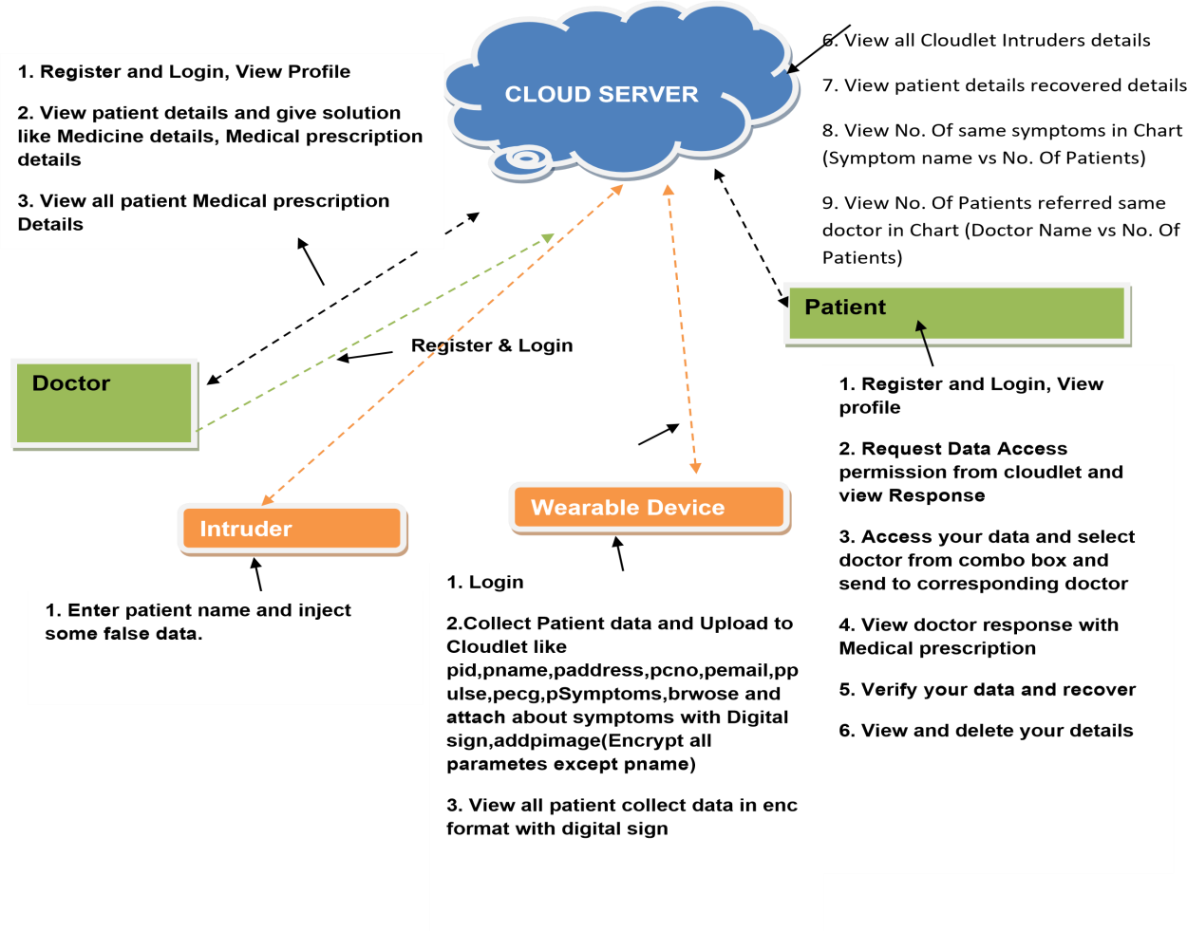View Patient data access request and authorize



24



# Flow Chart: Wearable Device



Start

Device Login

Yes

No

Login

**Collect Patient data and Upload to**

**Cloudlet**

Username &Password

Wrong

**View all patient collected data in enc**

**Format with digital sign**

Logout

### Flow Chart: Cloud Server

**Start**



**Cloud Server Login**

Yes No

**Login**

**View all patient and authorize**

**Username & Password Wrong**

**View all doctors and authorize**

**View all patient Cloudlet data with enc format**

**Log Out**

**View Patient data access request and authorize**

**View all Cloudlet Intruders details**

**View patient details recovered details**

**View No. Of same symptoms inChart**

**View No. Of Patients referred same doctor in Chart**

### FlowChart: Doctor



**Start**

**Doctor Login**

Yes

No

**Login**

**View patient details and give**

**solution**

**Username&**

**Password Wrong**

**View all patient Medical prescription**

**Details**

**LogOut**

* **FlowChart:Patient:**

**Start**



PatientLogin

Yes No

**Login**

**Request Data Access permission from cloudlet and view Response**

**Username & PasswordWrong**

Access Your data and select doctor

**LogOut**

**View doctor response with Medical prescription**

**Verify your data and recover**

**View and delete your data**

### 10. UML DIAGRAMS:

### 10.1 class diagrams:

Methods

Members

Methods

#### CloudServer

Login,View all patients and authorize, View all doctors and authorize,Vliew all patient Cloudlet data with enc format, View Patient dataaccessrequestand authorize,ViewallCloudletIntruders details, Viewpatientdetailsrecovereddetails,ViewNo.Ofsamesymptomsin Chart, View No. Of Patients refered same doctor in Chart,



Name, password, patientname, doctorname, chart, symptoms

Doctor

Register and Login,View Profile, View patient details and give solution like Medicine details, Medicalprescriptiondetails, View all patient Medical prescription Details

Name, password, address, email, contactnumber, prescriptiondetails, medicinedetails, patientdetails

##### Intruder

Enterpatientnameandinject some false data.

Patientname,wrongdata

Members

Methods

Members

Login(),Reset(), Register ().

User Name, Password.

Login,Register

UserName,Password

**Patient**

**Login**

Methods

Members

##### Register

Register(),Reset()

User Name, Password, E- mail, Mobile, Address, DOB, Gender, Pin code.

Methods

Members

Register and Login,View profile, Request Data Access permissionfromcloudletandviewResponse,AccessYourdata and select doctor from combo box and send to corresponding doctor, View doctor response with Medical prescription, Verify your data and recover, View and delete your details

Name, password, address, contactnumber, doctorname, medical prescription

##### WearableDevice

Login, Collect Patient data and Upload to Cloudlet, View all patient collect data in enc format with digital sign

Name,password,patientdata,pid,pname,paddress,pcno,pemail,ppulse,pecg,pSymptoms,brwose

### 10.2 sequencediagrams:



Server



**AddLogin details**

Device

Patient

Doctor

Attacker

**Viewall**

Cloud Provider

**Collect Patient data andUploadtoCloudlet**

**View all patient collecte data in enc format**

**Request Data Access permissionfrom cloudlet and**

**View patient details and givesolution**

**Viewall patient Medical**

**Enter patient name and injectsome false data.**

**patients, doctor**

**and authorize**

**View all patient Cloudlet data**

**View Patient data access request and authorize**

**View doctor responsewith Medical**

**Verifyyourdata and recover**

**View No. Of same symptoms, Patients refered same doctor in Char**

**View and delete your details**

**View patient details recovered**

**View all Cloudlet Intruder**

## 11. SOFTWARE ENVIRONMENT

Client Server

**Overview**:

With the varied topic in existence in the fields of computers, Client Server is one, which has generated more heat than light, and also more hype than reality. This technology has acquired a certain critical mass attention with its dedication conferences and magazines. Major computer vendors such as IBM and DEC, have declared that Client Servers is their main future market. A survey of DBMS magazine revealed that 76% of its readers were actively looking at the client server solution. The growth in the client server development tools from $200 million in 1992 to more than $1.2 billion in 1996.

Client server implementations are complex but the underlying concept is simple and powerful. A client is an application running with local resources but able to request the database and relate the services from separate remote server. The software mediating this client server interaction is often referred to as MIDDLEWARE.

The typical client either a PC or a Work Station connected through a network to a more powerful PC, Workstation, Midrange or Main Frames server usually capable of handling request from more thanoneclient.However,withsomeconfigurationservermay alsoactas client.Aservermayneed to access other server in order to process the original client request.

The key client server idea is that client as user is essentially insulated from the physical locationand formats of the data needs for their application. With the proper middleware, a client input from or report can transparently access and manipulate both local database on the client machine and remote databases on one or more servers. An added bonus is the client server opens the door to multi-vendor database access indulging heterogeneous table joins.

**What is a Client Server?**

Two prominent systems in existence are client server and file server systems. It is essential to distinguish between client servers and file server systems. Both provide shared network access to data but the comparison dens there! The file server simply provides a remote disk drive that can be accessedbyLANapplicationsonafilebyfilebasis.Theclientserveroffers fullrelationaldatabase services such as SQL-Access, Record modifying, Insert, Delete with full relational integritybackup/ restore performance for high volume of transactions, etc. the client server middleware provides a flexible interface between client and server, who does what, when and to whom.

**Why Client Server?**

Client server has evolved to solve a problem that has been around since the earliest days of computing: how best to distribute your computing, data generation and data storage resources in order to obtain efficient, cost effective departmental an enterprise wide data processing. During mainframe era choices were quite limited. A central machine housed both the CPU and DATA

(cards, tapes, drums and later disks).

Access to the resources was initially confined to batched runs that produced departmental reports at the appropriate intervals. A strong central information service department ruled the corporation. The role of the rest of the corporation limited to requesting new or more frequent reports and to provide hand written forms from which the central data banks were created and updated. The earliest client server solutions therefore could best be characterized as “SLAVE-MASTER”.

Client server has evolved to solve a problem that has been around since the earliest days of computing: how best to distribute your computing, data generation and data storage resources in order to obtain efficient, cost effective departmental anenterprise wide data processing. During mainframe era choices were quite limited. A central machine housed both the CPU and DATA (cards, tapes, drums and later disks). Access to these resources was initially confined to batched runs that produced departmental reports at the appropriate intervals. A strong central information service department ruled the corporation. The role of the rest of the corporation limited to requesting new or more frequent reports and to provide hand written forms from which the central data banks were created and updated. The earliest client server solutions therefore could best be characterized as “SLAVE-MASTER”.

Client server has evolved to solve a problem that has been around since the earliest days of computing: how best to distribute your computing, data generation and data storage resources in order to obtain efficient, cost effective departmental anenterprise wide data processing. During mainframe era choices were quite limited. A central machine housed both the CPU and DATA (cards, tapes, drums and later disks). Access to these resources was initially confined to batched runs that produced departmental reports at the appropriate intervals. A strong central information service department ruled the corporation. The role of the rest of the corporation limited to requesting new or more frequent reports and to provide hand written forms from which the central data banks were created and updated. The earliest client server solutions therefore could best be characterized as “SLAVE-MASTER”.

Time-sharing changed the picture. Remote terminal could view and even change the central data, subject to access permissions. And, as the central data banks evolved in to sophisticated relational database with non-programmer query languages, online users could formulate adhoc queries and produce local reports without adding to the MIS applications software backlog. However remote access was through dumb terminals, and the clients ever remained subordinate to the Slave\Master.

**11.1Front end or User Interface Design**

The entire user interface is planned to be developed in browser specific environment with a touchof Intranet-Based Architecture for achieving the Distributed Concept.

The browser specific components are designed by using the HTML standards, and the name is of the designed by concentrating on the constructs of the Java Server Pages.

Communication or Database Connectivity Tier

The Communication architecture is designed by concentrating on the Standards of Servlet and Enterprise Java Beans. The database connectivity is established by using the Java Data Base Connectivity.

The standards of three-tier architecture are given major concentration to keep the standards of higher cohesion and limited coupling for effectiveness of the operations.

Features Of The Language Used

In my project, I have chosen Java language for developing the code.

About Java

Initially the language was called as “oak” but it was renamed as “Java” in 1995. The primary motivationofthislanguagewastheneedforaplatform-independent(i.e.,architectureneutral) language that could be used to create softwareto beembedded in various consumer electronic devices.

* Java is a programmer’s language.
* Java is cohesive and consistent.
* Except for those constraints imposed by the Internet environment, Java gives the programmer, full control.

Finally, Java is to Internet programming where C was to system programming.

Importance of java to the internet

Java has had a profound effect on the Internet. This is because; Java expands the Universe of objects that can move about freely in Cyberspace. In a network, two categories of objects are transmitted between the Server and the Personal computer. They are: Passive information and Dynamic active programs. The Dynamic, Self-executing programs cause serious problems in the areas of Security and probability. But, Java addresses those concerns and by doing so, has opened the door to an exciting new form of program called the Applet.

Java can be used to create two types of programs

**Applications and Applets:** An application is a program that runs on our Computer under the operating system of that computer. It is more or less like one creating using C or C++. Java’sability to create Applets makes it important. An Applet is an application designed to be transmitted over the Internet and executed by a Java–compatible web browser. An applet is actually at any Java program, dynamically downloaded across the network, just like an image. But the difference is, it is an intelligent program, not just a media file. It can react to the user input and dynamically change.

**11.2 FEATURES OF JAVA**

**Security**

Every time you that you download a “normal” program, you are risking a viral infection. Prior to Java, most users did not download executable programs frequently, and those who did scanned them for viruses prior to execution. Most users still worried about the possibility of infecting their systems with a virus. In addition, another type of malicious program exists that must be guarded against. This type of program can gather private information, such as credit card numbers, bank account balances, and passwords. Java answers both these concerns by providing a “firewall” between a network application and your computer.When you use a Java-compatible Web browser, you can safely download Java applets without fear of virus infection or malicious intent.

Portability

For programs to be dynamically downloaded to all the various types of platforms connected to the Internet, some means of generating portable executable code is needed .As you will see, the same mechanism that helps ensure security also helps create portability. Indeed, Java’s solution to these two problems is both elegant and efficient.

TheBytecode

Thekey that allowsthe Javato solve thesecurity and portability problems is that theoutput ofJava compiler is Byte code. Byte code is a highly optimized set of instructions designed to be executed by the Java run-time system, which is called the Java Virtual Machine (JVM). That is, in its standard form, the JVM is an interpreter for byte code.

Translating a Java program into byte code helps makes it much easier to run a program in a wide variety of environments. The reason is, once the run-time package exists for a given system, any Java program can run on it.

Although Java was designed for interpretation, there is technically nothing about Java that prevents on-the-fly compilation of byte code into native code. Sun has just completed its Just In Time (JIT) compiler for byte code. When the JIT compiler is a part of JVM, it compiles byte code into executable code in real time, on a piece-by-piece, demand basis. It is not possible to compile an entire Java program into executable code all at once, because Java performs various run-timechecks that can be done only at run time. The JIT compiles code, as it is needed, during execution.

JavaVirtualMachine(JVM)

Beyond the language, there is the Java virtual machine. The Java virtual machine is an important element of the Java technology. The virtual machine can be embedded within a web browser or anoperating system.

Once a piece of Java code is loaded onto a machine, it is verified. As part of the loading process, a class loader is invoked and does byte code verification makes sure that the code that’s has been generated by the compiler will not corrupt the machine that it’s loaded on. Byte code verification takes place at the end of the compilation process to make sure that is all accurate and correct. So byte code verification is integral to the compiling and executing of Java code.

**Overall Description**

JavaSource

**Javabytecode**

Java**VM**

java .class

**PictureshowingthedevelopmentprocessofJAVAProgram**

Java programming uses to produce byte codes and executes them. The first box indicates that the Java source code is located in a. Java file that is processed with a Java compiler called javac. The Java compiler produces a file called a. class file, which contains the byte code. The .Class file is thenloadedacrossthenetworkorloadedlocallyonyourmachineintotheexecutionenvironmentis the Java virtual machine, which interprets and executes the byte code.

JavaArchitecture

Java architecture provides a portable, robust, high performing environment for development. Java provides portability by compiling the byte codes for the Java Virtual Machine, which is then interpreted on each platform by the run-time environment. Java is a dynamic system, able to load code when needed from a machine in the same room or across the planet.

Compilationofcode

When you compile the code, the Java compiler creates machine code (called byte code) for a hypotheticalmachinecalledJavaVirtualMachine(JVM).TheJVMissupposedtoexecutethebyte code. TheJVM is created forovercoming the issue ofportability. Thecode is written and compiled for one machine and interpreted on all machines. This machine is called Java Virtual Machine.

During run-time the Java interpreter tricks the byte code file into thinking that it is running on a Java Virtual Machine. In reality this could be a Intel Pentium Windows 95 or Sun SARC station running Solaris or Apple Macintosh running system and all could receive code from any computer through Internet and run the Applets.

***CompilingandinterpretingJavaSourceCode.***

**Java**

PCCompiler

**Java**

**Interpreter**

**Source**

**(PC)**

**Code**

**Macintosh**

**Bytecode**

**Java**

**………..**

**Compiler**

**Interpreter**

**………..**

**(Platform**

**(Macintosh)**

**SPARC**

**Independe**

**-nt)**

**Java**

**Interpreter**

**(Sparc)**

Simple

Java was designed to be easy for the Professional programmer to learn and to use effectively. If you are an experienced C++ programmer, learning Java will be even easier. Because Java inherits the C/C++ syntax and many of the object oriented features of C++. Most of the confusing concepts from C++ are either left out of Java or implemented in a cleaner, more approachable manner. In Java there are a small number of clearly defined ways to accomplish a given task.

Object-Oriented

Java was not designed to be source-code compatible with any other language. This allowed the Java team the freedom to design with a blank slate. One outcome of this was a clean usable, pragmatic approach to objects.

The object model in Java is simple and easy to extend, while simple types, such as integers, are kept as high-performance non-objects.

Robust

The multi-platform environment of the Web places extraordinary demands on a program, because the program must execute reliably in a variety of systems. The ability to create robustprogramswas given a high priority in the design of Java. Java is strictly typed language; it checks your code at compile time and run time.

Java virtually eliminates the problems of memory management and de-allocation, which is completely automatic. In a well-written Java program, all run time errors can –and should –be managed by your program.

**11.3 JAVASCRIPT**

JavaScript is a script-based programming language that was developed by Netscape Communication Corporation. JavaScript was originally called Live Script and renamed as JavaScript to indicate its relationship with Java. JavaScript supports the development of both client and server components of Web-based applications. On the client side, it can be used to write programs that are executed by a Web browser within the context of a Webpage. On these ever side, it can be used to write Web server programs that can process information submitted by a Web browser and then update the browser’s display accordingly

Even though JavaScript supports both client and server Web programming, we prefer JavaScript at Client side programming since most of the browsers supports it. JavaScript is almost as easy to learn as HTML, and JavaScript statements can be included in HTML documents by enclosing the statements between a pair of scripting tags

<SCRIPTS>..</SCRIPT>.

<SCRIPTLANGUAGE=“JavaScript”>

JavaScriptstatements

</SCRIPT>

Here are a few things we can do with Java Script:

* Validate the contents of a formed make calculations.
* Add scrolling or changing messages to the Browser’s status line.
* Animate image so rotate images that change when we move the mouse over them.
* Detect the browser in use and display different content for different browsers.
* Detect installed plug-ins and notify the user if a plug-in is required. We can do much more with JavaScript, including creating entire application.

Java Script vs Java

Java Script and Java are entirely different languages. A few of them differences are:

* Java applets are generally displayed in a box within the web document; Java Script can affect any part of the Web document itself.
* WhileJavaScript is best suited to simple applications and adding interactivefeatures to Web pages; Java can be used for incredibly complex applications.

There are many other differences but the important thing to remember is thatJavaScript and Java are separate languages. They are both useful for different things; in fact they can be used togetherto combine their advantages.

Advantages

* Java Script can be used for Sever-side and Client-side scripting.
* It is more flexible than VB Script.
* Java Script is the default scripting languages at Client-side since all the browsers supports it.

11.4 Hyper Text Markup Language

Hypertext Markup Language (HTML), the languages of the World Wide Web (WWW), allows users to produces Web pages that include text, graphics and pointer to other Web pages (Hyperlinks).

HTML is not a programming language but it is an application of ISO Standard 8879, SGML (Standard Generalized Markup Language), but specialized to hypertext and adapted to the Web. The idea behind Hypertext is that instead of reading text in rigid linear structure, we can easily jump from one point to another point. We can navigate through the information based on our interest and preference. A markup language is simply a series of elements, each delimited with special characters that define how text or other items enclosed within the elements should be displayed. Hyper links are underlined or emphasized works that load to other documents or some portions of the same document.

HTML can be used to display any type of document on the host computer, which can be geographically at a different location. It is a versatile language and can be used on any platform or desktop.

HTML provides tags (special codes) to make the document look attractive. HTML tags are not case-sensitive. Using graphics, fonts, different sizes, color, etc., can enhance the presentation of the document. Anything that is not a tag is part of the document itself.

BasicHTMLTags:

**<!-- -->** Specifies comments

**<A>……….</A>** Creates hyper text links

**<B>………. </B>** Formats text as bold

**<BIG>……….</BIG>** Formats text in large font.

**<BODY>…</BODY>** Contains all tags and text in the HTML document

**<CENTER>...</CENTER>** Creates text

**<DD>…</DD>** Definition of a term

**<DL>...</DL>** Creates definition list

**<FONT>…</FONT>** Formats text with a particular font

**<FORM>...</FORM>** Encloses a fill-outform

**<FRAME>...</FRAME>** Defines a particular frame in a set of frames

**<H#>…</H#>** Creates headings of different levels

**<HEAD>...</HEAD>** Contains tags that specify information about a document

**<HR>...</HR>** Creates a horizontal rule

**<HTML>…</HTML>** Contains all other HTML tags

**<META>...</META>** Provides meta-information about a document

**<SCRIPT>…</SCRIPT>** Contains client-side or server-side script

**<TABLE>…</TABLE>** Creates a table

**<TD>…</TD>** Indicates table data in a table

**<TR>…</TR>** Designates a table row

**<TH>…</TH>** Creates a heading in a table

###### ADVANTAGES

* A HTML document is small and hence easy to send over the net. It is small because it does not include formatted information.
* HTML is platform independent.
* HTML tags are not case-sensitive.

11.5 Java Database Connectivity

What Is JDBC?

JDBC is a Java API for executing SQL statements. (As a point of interest, JDBC is a trademarked name and is not an acronym; nevertheless, JDBC is often thought of as standing for Java Database Connectivity. It consists of a set of classes and interfaces written in the Java programming language. JDBC provides a standard API for tool/database developers and makes it possible towrite database applications using a pure Java API.

Using JDBC, it is easy to send SQL statements to virtually any relational database. One can write a single program using the JDBC API, and the program will be able to send SQL statements to the appropriate database. The combinations of Java and JDBC lets a programmer write it once and run it anywhere.

What Does JDBC Do?

Simply put, JDBC makes it possible to do three things:

* Establish a connection with a database
* Send SQL statements
* Process the results.

JDBC versus ODBC and other APIs

At this point, Microsoft's ODBC (Open Database Connectivity) API is that probably the most widely used programming interface for accessing relational databases. It offers the ability to connect to almost all databases on almost all platforms.

So why not just use ODBC from Java? The answer is that you can use ODBC from Java, but this is best done with the help of JDBC in the form of the JDBC-ODBC Bridge, which we will cover shortly. The question now becomes "Why do you need JDBC?" There are several answers to this question:

* 1. ODBC is not appropriate for direct use from Java because it uses a C interface. Calls from Java to native C code have a number of drawbacks in the security, implementation, robustness, and automatic portability of applications.
  2. A literal translation of the ODBC C API into a Java API would not be desirable. For example, Java has no pointers, and ODBC makes copious use of them, including the notoriously error-prone generic pointer "void *". You can think of JDBC as ODBC translated into an object-oriented interface that is natural for Java programmers.
  3. ODBC is hard to learn. It mixes simple and advanced features together, and it has complex options even for simple queries. JDBC, on the other hand, was designed to keep simple things simple while allowing more advanced capabilities where required.
  4. A Java API like JDBC is needed in order to enable a "pure Java" solution. When ODBC is used, the ODBC driver manager and drivers must be manually installed on every client machine. When the JDBC driver is written completely in Java, however, JDBC code is automatically installable, portable, and secure on all Java platforms from networkcomputers to mainframes.

**Two-tierandThree-tierModels**

**Client machine**

**JAVA**

**Application**

**JDBC**

**DBMS**

**DBMS-proprietary protocol**

**Database server**

The JDBC API supports both two-tier and three-tier models for database access.

**Javaappletor**

**Htmlbrowser**

**Application Server (Java)**

**JDBC**

DBMS

**Clientmachine(GUI)**

**HTTP,RMI,orCORBAcalls**

**Servermachine(businessLogic)**

**Databaseserver**

In the two-tier model, a Java applet or application talks directly to the database. This requires a JDBC driver that can communicate with the particular database management system being accessed. A user's SQL statements are delivered to the database, and the results of those statements are sent back to the user.

Thedatabasemaybelocatedonanothermachine towhichtheuseris connectedviaanetwork.This is referred to as a client/server configuration, with the user's machine as the client, and the machine housing the database as the server. The network can be an Intranet, which, for example, connects employees within a corporation, or it can be the Internet.In the three-tier model, commands are sent to a "middle tier" of services, which then send SQL statements to the database. The database processes the SQL statements and sends the results back to the middle tier, which then sends them to the user. MIS directors find the three-tier model very attractive because the middle tier makes it possible to maintain control over access and the kinds of updates that can be made to corporatedata. Another advantage is that when there is a middle tier, the user can employ an easy-to-use higher-level API which is translated by the middle tier into the appropriate low-level calls. Finally, in many cases the three-tier architecture can provide performance advantages.

Until nowthemiddletier has typically been writtenin languages such as C orC++, which offer fast performance. However, with the introduction of optimizing compilers that translate Java bytecodeintoefficient machine-specificcode,itisbecomingpracticalto implementthemiddle tier in Java. This is a big plus, making it possible to take advantage of Java's robustness, multithreading, and security features. JDBC is important to allow database access from a Java middle tier.

11.5.1 JDBC Driver Types

The JDBC drivers that we are aware of at this time fit into one of four categories:

* JDBC-ODBC bridge plus ODBC driver
* Native-API partly-Java driver
* JDBC-Net pure Java driver
* Native-protocol pure Java driver

JDBC-ODBC Bridge

If possible, use a Pure Java JDBC driver instead of the Bridge and an ODBC driver. This completely eliminates the client configuration required by ODBC. It also eliminates the potential that the Java VM could be corrupted by an error in the native code brought in by the Bridge (that is, the Bridge native library, the ODBC driver manager library, the ODBC driver library, and the database client library).

What Is the JDBC-ODBC Bridge?

The JDBC-ODBC Bridge is a JDBC driver, which implements JDBC operations by translating them into ODBC operations. To ODBC it appears as a normal application program. The Bridge implements JDBC for any database for which an ODBC driver is available. The Bridge is implemented as the sun.jdbc.odbc Java package and contains a native library used to access ODBC. The Bridge is a joint development of Intersolv and JavaSoft.

11.6 Java Server Pages(JSP)

Java server Pages is a simple, yet powerful technology for creating and maintaining dynamic- content web pages. Based on the Java programming language, Java Server Pages offers proven portability, open standards, and mature re-usable component model .The Java Server Pages architecture enables the separation of content generation from content presentation. This separation not eases maintenance headaches; it also allows web team members to focus on their areas of expertise. Now, web page designer can concentrate on layout, and web application designers on programming, with minimal concern about impacting each other’s work.

Features of JSP Portability:

Java Server Pages files can be run on any web server or web-enabled application server that provides support for them. Dubbed the JSP engine, this support involves recognition, translation, and management of the Java Server Page lifecycle and its interaction components.

Components

It was mentioned earlier that the Java Server Pages architecture can include reusable Java components. The architecture also allows for the embedding of a scripting language directly intothe Java Server Pages file. The components current supported include Java Beans, and Servlet.

Processing

A Java Server Pages file is essentially an HTML document with JSP scripting or tags. The Java Server Pages file has a JSP extension to the server as a Java Server Pages file. Before the page is served, the Java Server Pages syntax is parsed and processed into a Servlet on the server side. The Servlet that is generated outputs real content in straight HTML for responding to the client.

AccessModels*:*

A Java Server Pages file may be accessed in at least two different ways. A client’s request comes directly into a Java Server Page. In this scenario, suppose the page accesses reusable Java Bean components that perform particularwell-defined computations likeaccessing adatabase. Theresult of the Beans computations, called result sets is stored within the Bean as properties. The page uses

such Beans to generate dynamic content and present it back to the client.

In both of the above cases, the page could also contain any valid Java code. Java Server Pages architecture encourages separation of content from presentation.

**Steps in the execution of a JSP Application:**

* The client sends a request to the web server for a JSP file by giving the name of the JSP file within the form tag of a HTML page.
* This request is transferred to the Java Web Server. At the server side Java Web Server receives the request and if it is a request for a jsp file server gives this request to the JSP engine.
* JSP engine is program which can understand the tags of the jsp and then it converts those tags into a Servlet program and it is stored at the server side. This Servlet is loaded in the memoryandthenitisexecutedandtheresult isgivenbacktothe JavaWeb Serverandthen it is transferred back to the result is given back to the JavaWebServer and then it is transferred back to the client.

JDBC connectivity

The JDBC provides database-independent connectivity between the J2EE platform and a wide range of tabular data sources. JDBC technology allows an Application Component Provider to:

* + Perform connection and authentication to a database server
  + Manager transactions
  + Move SQL statements to a database engine for preprocessing and execution
  + Executes to reprocedures
  + Inspect and modify the results from Select statements.

11.7 Tomcat 6.0 web server

Tomcat is an open source web server developed by Apache Group. Apache Tomcat is the Servlet container that is used in the official Reference Implementation for the Java Servlet and Java Server Pages technologies. The Java Servlet and Java Server Pages specifications are developed by Sun under the Java Community Process. Web Servers like Apache Tomcat support only web components while an application server supports web components as well as business components (BEAs Web logic, is one of the popular application server).To develop a web application with jsp/servlet install any web server like JRun, Tomcat etc to run your application.

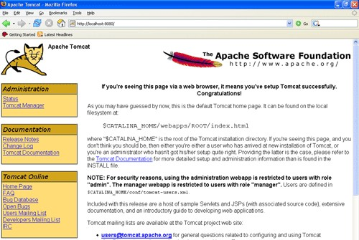

## 12. SYSTEM TESTING

The purpose of testing is to discover errors. Testing is the process of trying to discover every conceivable fault or weakness in a work product. It provides a way to check the functionality of components, sub assemblies, assemblies and/or a finished product It is the process of exercising softwarewiththeintentofensuringthattheSoftwaresystemmeetsitsrequirementsanduser expectations and does not fail in an unacceptable manner. There are various types of test. Eachtest type addresses a specific testing requirement.

12.1 TYPES OF TESTS

**Unit testing**

Unit testing involves the design of test cases that validate that the internal program logic is functioning properly, and that program inputs produce valid outputs. All decision branches and internal code flow should be validated. It is the testing of individual software units of the application .it is done after the completion of an individual unit before integration. This is a structural testing, that relies on knowledge of its construction and is invasive. Unit tests perform basic tests at component level and test a specific business process, application, and/or system configuration. Unit tests ensure that each unique path of a business process performs accurately to the documented specifications and contains clearly defined inputs and expected results.

**Integration testing**

Integration tests are designed to test integrated software components to determine if the actually run as one program.Testing is event driven and is more concerned with the basic outcome of screens or fields. Integration tests demonstrate that although the components were individually satisfaction, as shown by successfully unit testing, the combination of components is correct and consistent. Integration testing is specifically aimed atexposing the problems that arise from the combination of components.

**Functional test**

Functional tests provide systematic demonstrations that functions test vailableas specified by the business and technical requirements, system documentation, and user manuals.

Functional testing is centered on the following items:

Valid Input :identified classes of valid input must be accepted. Invalid Input :identified classes so fin valid input must be rejected. Functions : identified functions must be exercised.

Output :identified classes of application outputs must be exercised. Systems/Procedures: interfacing systems or procedures must be invoked.

Organization and preparation of functional tests is focused on requirements, key functions, or special test cases. In addition, systematic coverage pertaining to identify Business process flows; data fields, predefined processes, and successive processes must be considered for testing.Before functional testing is complete, additional tests are identified and the effective value of current tests is determined.

System Test

System testing ensures that the entire integrated software system meets requirements. It tests a configuration to ensure known and predictable results. An example of system testing is the configuration oriented system integration test. System testing is based on process descriptions and flows, emphasizing pre-driven process links and integration points.

White Box Testing

White Box Testing is a testing in which in which the software tester has knowledge of the inner workings, structure and language of the software, or at least its purpose. It is purpose. It is usedto test areas that cannot be reached from a black box level.

Black Box Testing

Black Box Testing is testing the software without any knowledge of the inner workings, structure or language of the module being tested. Black box tests, as most other kinds of tests, must be written from a definitive source document, such as specification or requirements document, such as specification or requirements document. It is a testing in which the software under test is treated, as a black box .you cannot “see” into it. The test provides inputs and responds to outputs without considering how the software works.

* **Unit Testing:**

Unit testing is usually conducted as part of a combined code and unit test phase of the software lifecycle, although it is not uncommon for coding and unit testing to be conducted as two distinct phases.

**Test strategy and approach**

Field testing will be performed manually and functional tests will be written in detail.

**Test objectives**

* All field entries must work properly.
* Pages must be activated from the identified link.
* Then try screen, messages and responses must not be delayed.

**Features to be tested**

* Verify that the entries are of the correct format
* No duplicate entries should be allowed
* All links should take the user to the correct page.
* IntegrationTesting

Software integration testing is the incremental integration testing of two or more integrated software components on a single platform to produce failures caused by interface defects.

The task of the integration test is to check that components or software applications, e.g. components in a softwaresystem or – onestep up – softwareapplications at the company level – interact without error.

**Test Results:** All the test cases mentioned above passed successfully. No defects en countered.

* AcceptanceTesting

User Acceptance Testing is a critical phase of any project and requires significant participation by the end user. It also ensures that the system meets the functional requirements.

**Test Results:** All the test cases mentioned above passed successfully. No defects encountered.

###### TESTING METHODOLOGIES

The following are theTesting Methodologies:

* Unit Testing.
* IntegrationTesting.
* UserAcceptanceTesting.
* Output Testing.
* ValidationTesting.

Unit Testing

Unit testing focuses verification effort on the smallest unit of Software design that is the module. Unit testing exercises specific paths in a module’s control structure to ensure complete coverage and maximum error detection. This test focuses on each module individually, ensuring that it functions properly as a unit. Hence, the naming is Unit Testing.

During this testing, each module is tested individually and the module interfaces are verified for the consistency with design specification. All important processing path are tested for the expected results. All error handling paths are also tested.

IntegrationTesting

Integration testing addresses the issues associated with the dual problems of verification and program construction. After the software has been integrated a set of high order tests are conducted. The main objective in this testing process is to take unit tested modules and builds a program structure that has been dictated by design.

Thefollowingarethetypes of Integration Testing:

1. Top Down Integration

This method is an incremental approach to the construction of program structure. Modules are integrated by moving downward through the control hierarchy, beginning with the main program module. The module subordinates to the main program module are incorporated into the structure in either a depth first or breadth first manner.

In this method, the software is tested from main module and individuals tubs are replaced when the test proceeds downwards.

1. Bottom-up Integration

This method begins the construction and testing with the modules at the lowest level in the program structure. Since the modules are integrated from the bottom up, processing required for modules subordinate to a given level is always available and the need for stubs is eliminated. The bottom up integration strategy may be implemented with the following steps:

* + The low-level modules are combined into clusters into clusters that perform a specific Software sub-function.
  + A driver (i.e.) the control program for testing is written to coordinate test case Input and output.
  + Theclusteristested.
  + Drivers are removed and clusters are combined moving upward in the program structure

The bottomup approaches tests each module individually and the n each module is module is integrated with a main module and tested for functionality.

###### OTHER TESTING METHODOLOGIES

User Acceptance Testing

User Acceptance of a system is the key factor for the success of any system. The system under consideration is tested for user acceptance by constantly keeping in touch with the prospective system users at the time of developing and making changes wherever required. The system developed provides a friendly user interface that can easily be understood even by a person who is new to the system.

Output Testing

After performing the validation testing, the next step is output testing of the proposed system, since no system could be use fluidity does not produce the required output in the specified format. Asking the users about the format required by them tests the outputs generated or displayed by the system under consideration.Hence the output format is considered in 2 ways – one is on screen and another in printed format.

Validation Checking

Validation checks are performed on the following fields.

Text Field:

The text field can contain only the number of characters lesser than or equal to its size. The text fields are alphanumeric in some tables and alphabetic in other tables.Incorrect entry always flashes and error message.

Numeric Field:

The numeric field can contain only numbers from 0 to 9. An entry of any character flashes an error messages. The individual modules are checked for accuracy and what it has to perform.Each module is subjected to testrun along with sample data.The individually tested modulesare integrated into a single system.Testing involves executing the real data information is used in the program the existence of any program defect is inferred from the output.The testing should be planned sothat all the requirements are individually tested.

A successful testis one that gives out the defects for the in appropriate data and produces and output revealing the errors in the system.

Preparation of Test Data

Taking various kinds of test data does the above testing. Preparation of test data plays a vital role in the system testing. After preparing the test data the system under study is testedusing that test data. While testing the system by using test data errors are again uncovered and corrected by using above testing steps and corrections are also noted for future use.

Using Live Test Data:

Live test data are those that are actually extracted from organization files. After a system is partially constructed, programmers or analysts often ask usersto key in a set ofdatafromtheir normal activities. Then, the systems person uses this data as a way to partially test the system. In other instances, programmers or analysts extract a set of live data from the files and have they entered themselves.

It is difficult to obtain live data in sufficient amounts to conduct extensive testing. And, although it is realistic data that will show how the system will perform for the typical processing requirement, assuming that the live data entered are in fact typical, such data generally will not test all combinations or formats that can enter the system. This bias toward typical values then does not provide a true systems test and in fact ignores the cases most likely to cause system failure.

Using Artificial Test Data:

Artificial test data are created solely for test purposes, since they can be generated to test all combinations of formats and values. In other words, the artificial data, which can quickly be prepared by a data generating utility program in the information systems department, make possible the testing of all login and control paths through the program.

The most effective test programs use artificial test data generated by persons other than those who wrote the programs. Often, an independent team of testers formulates a testing plan, using the systems specifications.

The package “Virtual Private Network” has satisfied all the requirements specified as per software requirement specification and was accepted.

###### USER TRAINING

Whenever a new system is developed, user training is required to educate them about theworking of the system so that it can be put to efficient use by those for whom the system hasbeenprimarilydesigned. For this purpose the normal working of the project was demonstrated to the prospective users. Its working is easily understandable and since the expected users are people who have good knowledge of computers, the use of this system is very easy.

###### MAINTAINENCE

This covers a wide range of activities including correcting code and design errors. To reduce the need for maintenance in the long run, we have more accurately defined the user’s requirements during the process of system development. Depending on the requirements, this system has been developed to satisfy the needs to the largest possible extent. With development in technology, it may be possible to add many more features based on the requirements in future. The coding and designing is simple and easy to understand which will make maintenance easier.

###### TESTING STRATEGY:

A strategy for system testing integrates system test cases and design techniques into a well planned series of steps that results in the successful construction ofsoftware.Thetestingstrategy must co-operate test planning, test case design, test execution, and theresultant data collection and evaluation .A strategy for software testingmustaccommodatelow-levelteststhat are necessaryto verify that a small source code segment has been correctlyimplementedas well as highleveltests thatvalidatemajorsystem functions against user requirements.

Software testing is a critical element of software quality assurance and represents the ultimate review of specification design and coding. Testing represents an interesting anomaly for the software. Thus, a series of testing are performed for the proposed system before the system is ready for user acceptance testing.

**13. SCREENSHOTS**

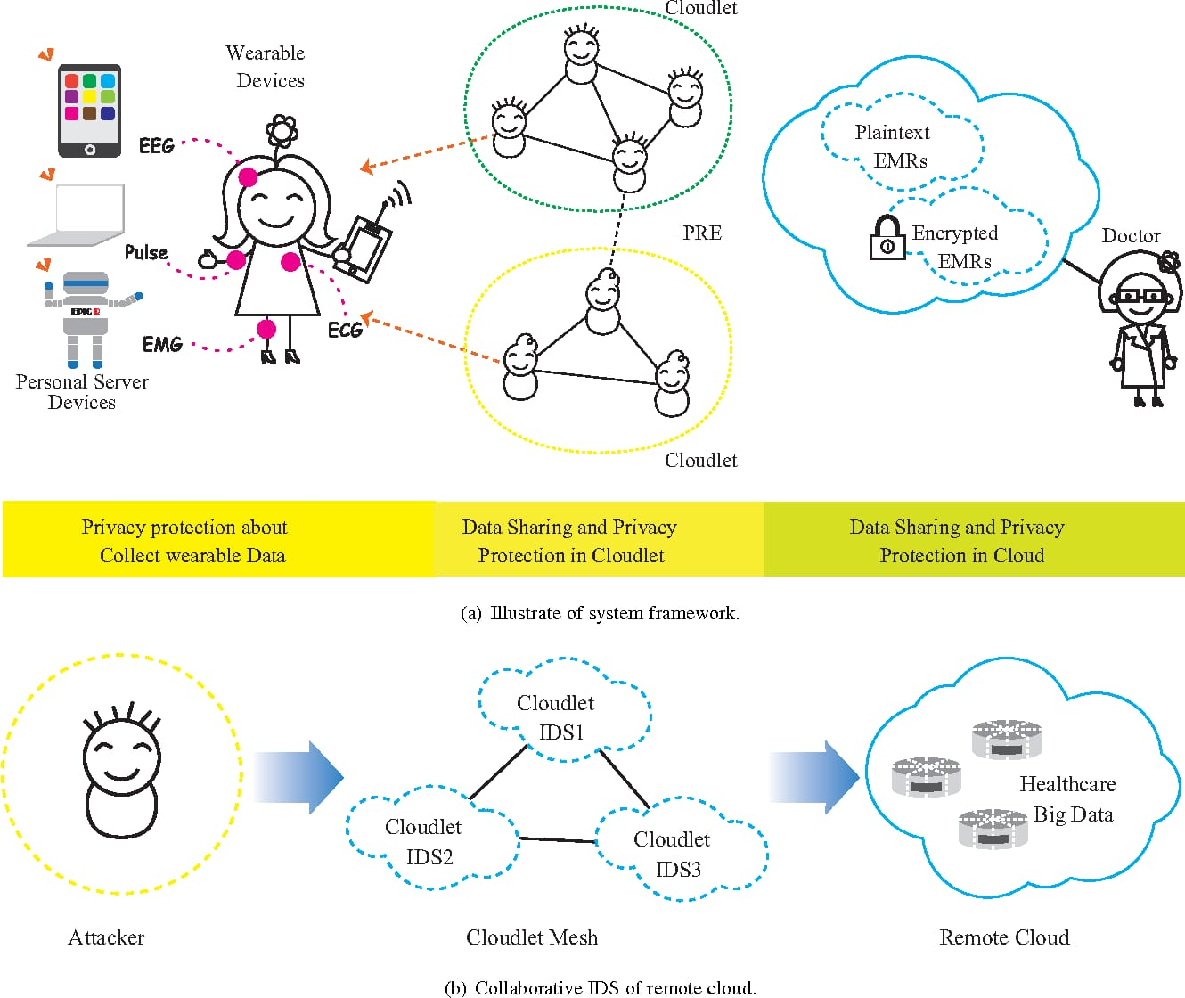

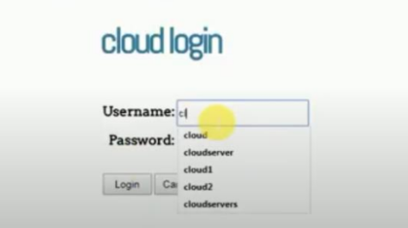

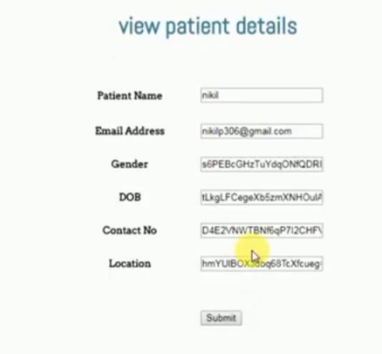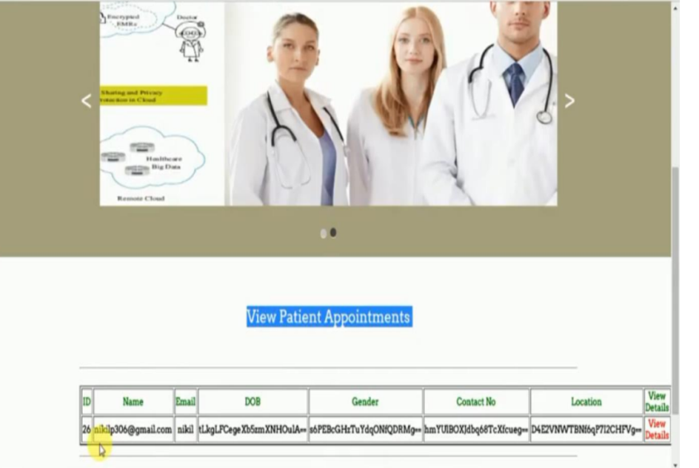

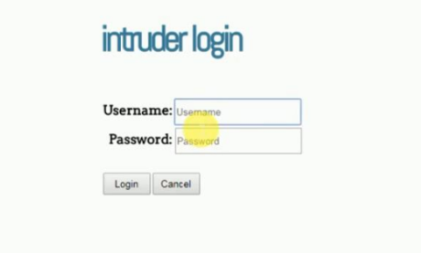

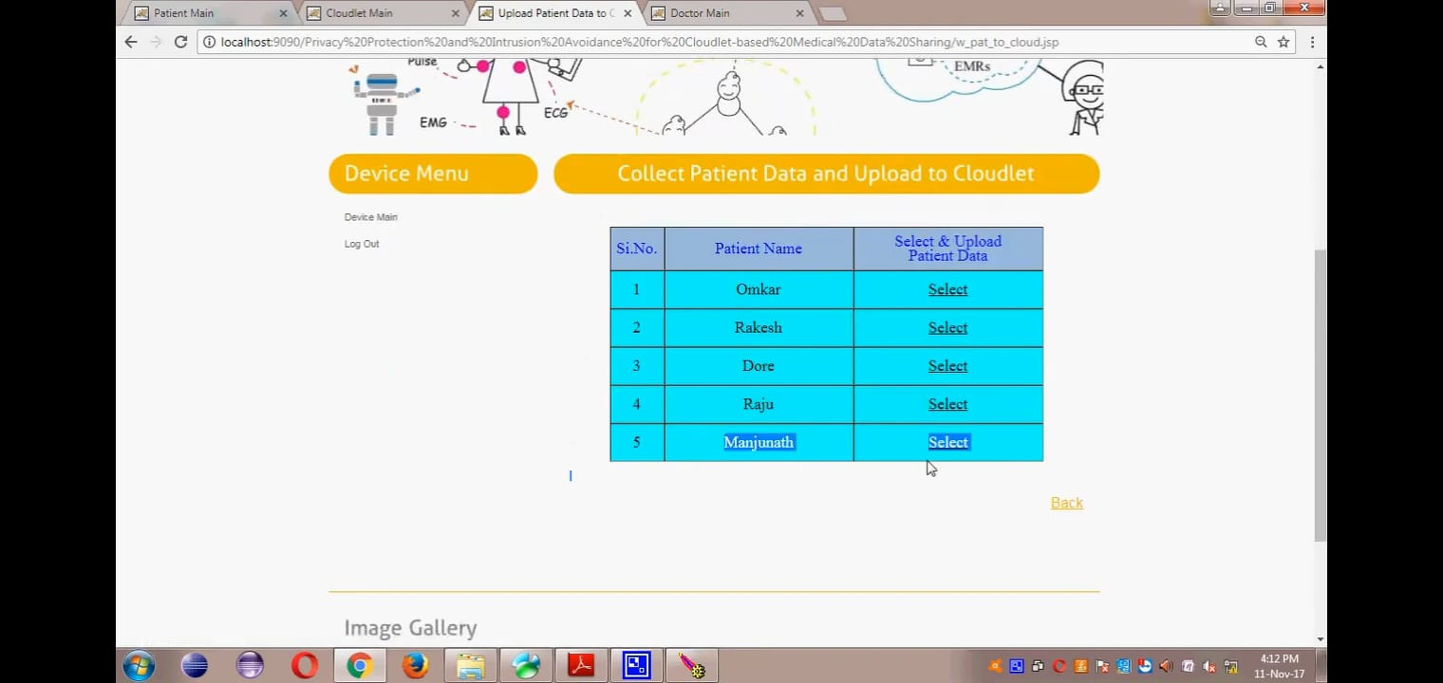

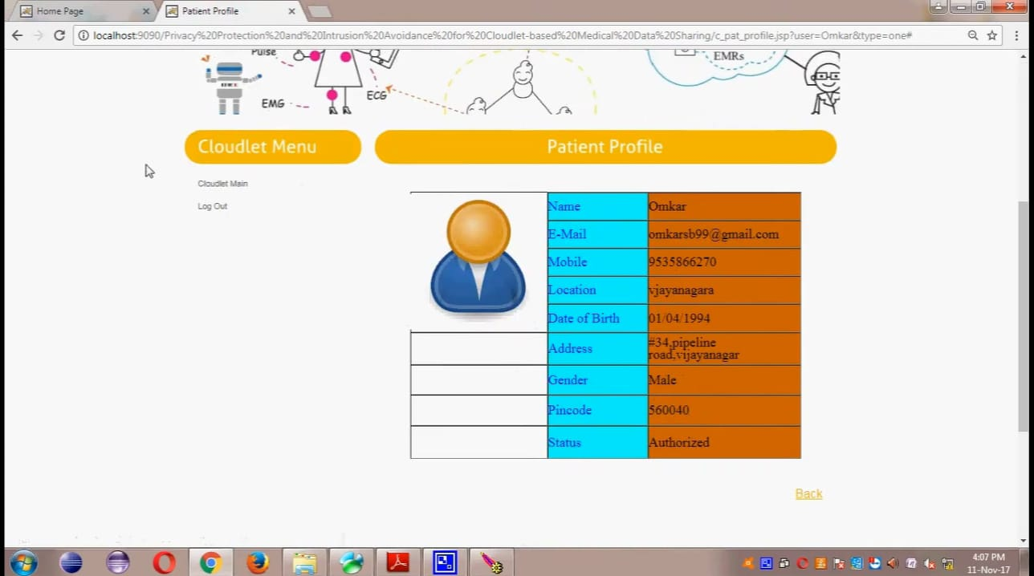

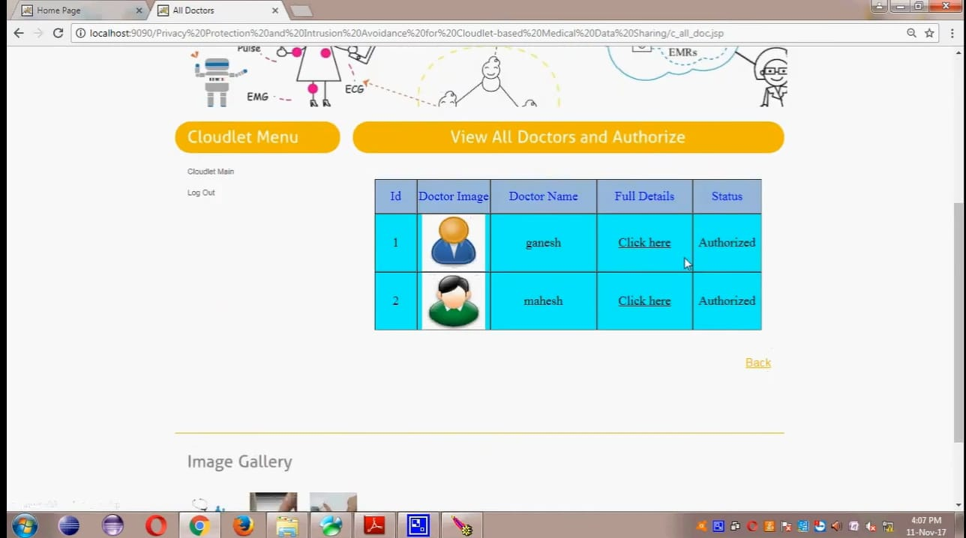

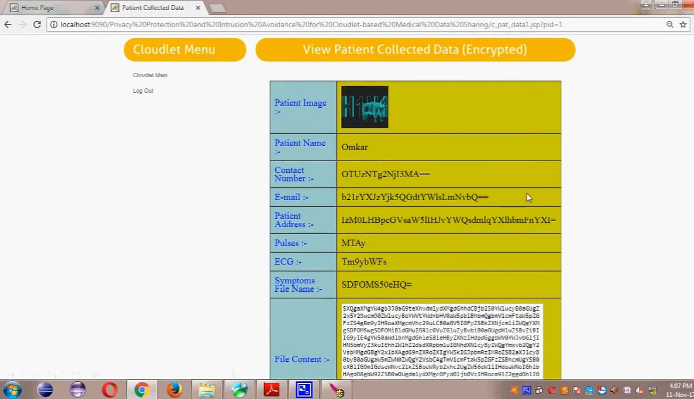

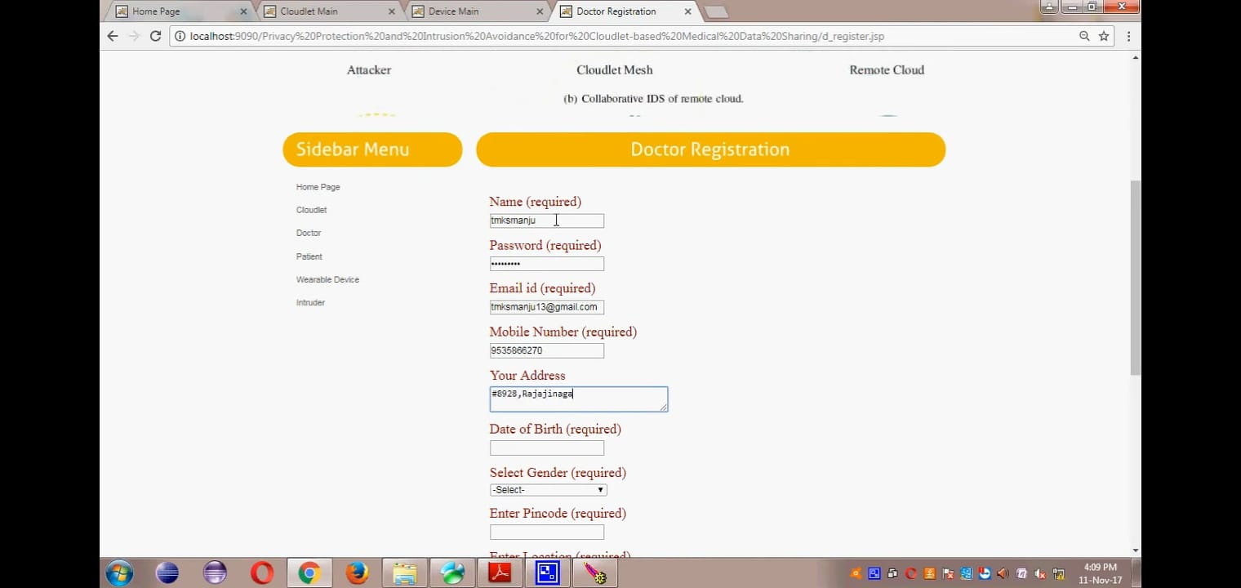

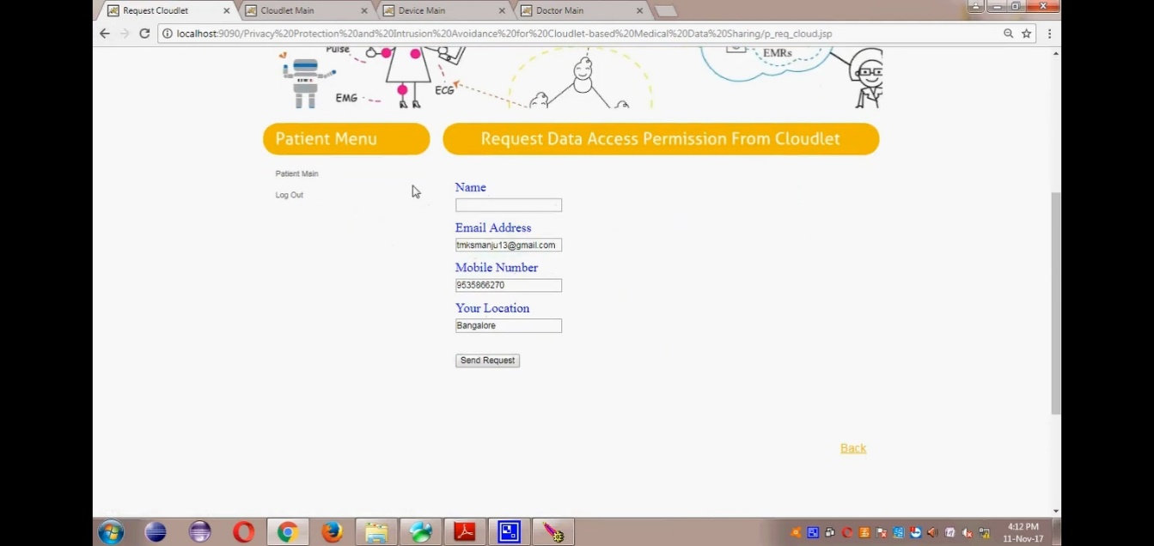



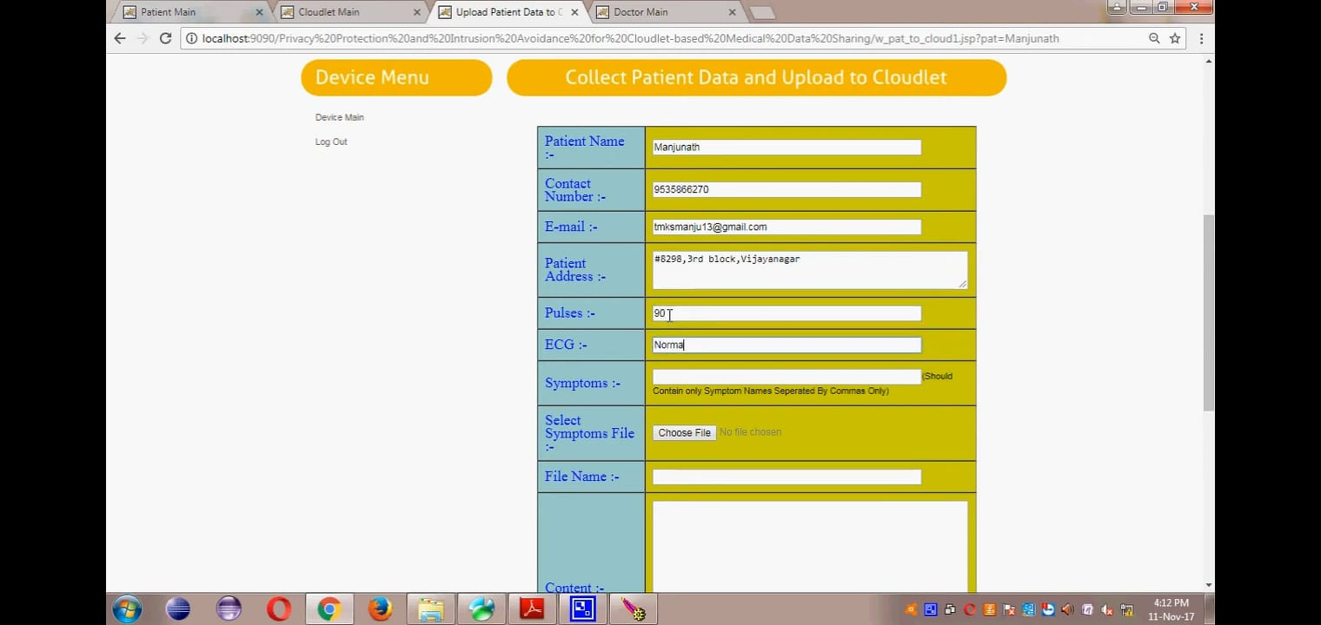

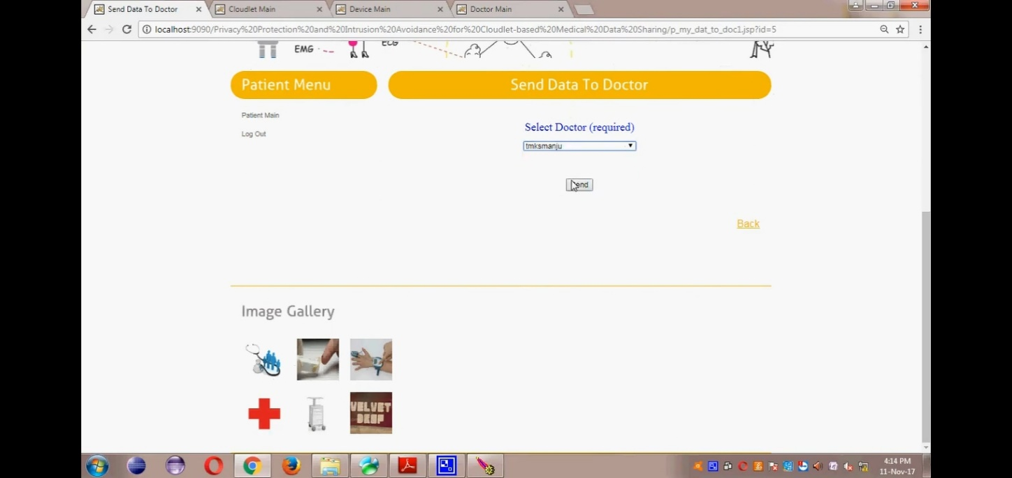

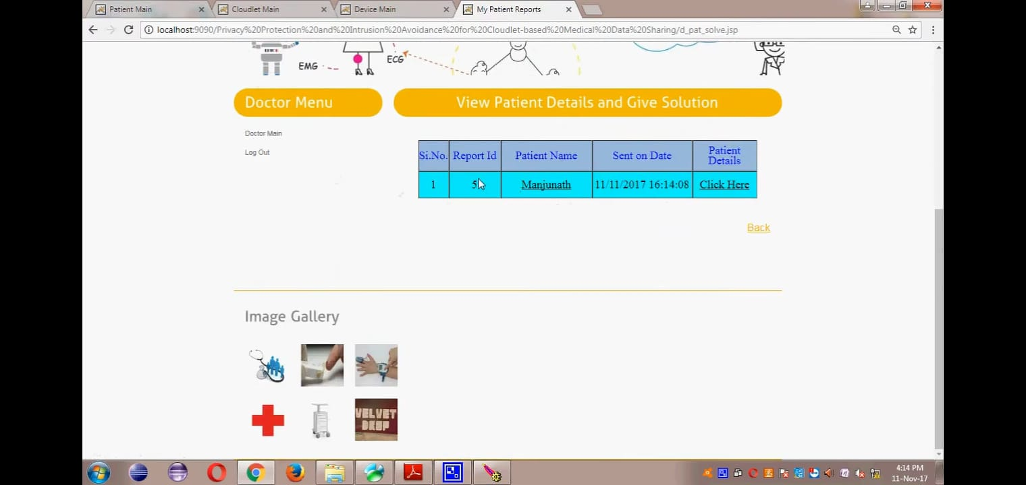

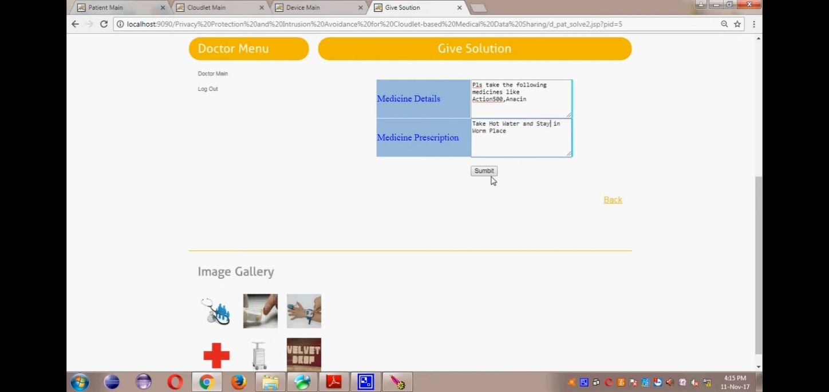

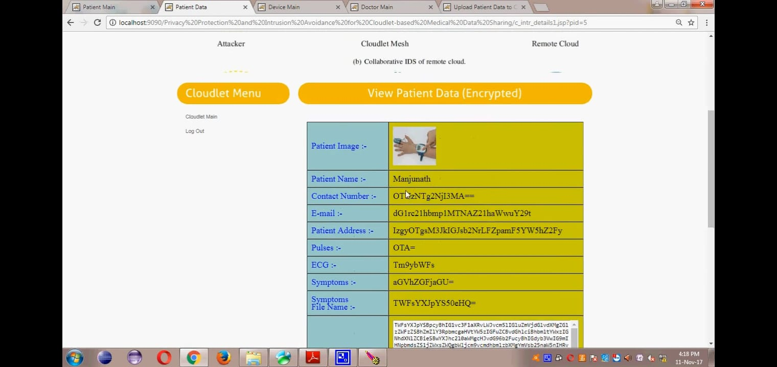

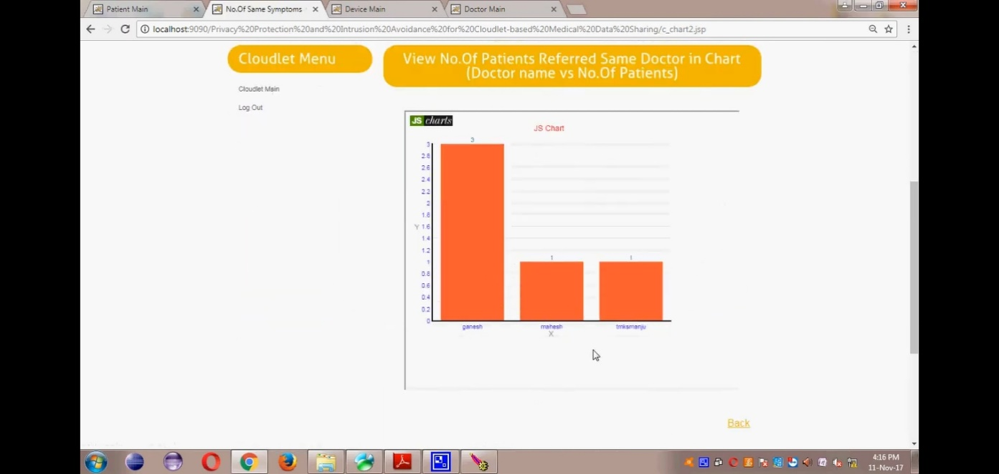14. **CONCLUSION**

In this paper, we investigated the problem of privacy protection and sharing large medical data in cloudlets and the remote cloud. We developed a system which does not allow users to transmit data to the remote cloud in consideration of secure collection of data, as well as low communication cost. However, it does allow users to transmit data to a cloudlet, which triggers the data sharing problem in the cloudlet.

Firstly, we can utilize wearable devices to collect users’ data, and in order to protect users privacy, we use NTRU mechanism to make sure the transmission of users’ data to cloudlet in security. Secondly, for the purpose of sharing data in the cloudlet, we use trust model to measure users’ trust level to judge whether to share data or not. Thirdly, for privacy-preserving of remote cloud data, we partition the data stored in the remote cloud and encrypt the data in different ways, so as to not just ensure data protection but also accelerate the efficacy of transmission. Finally, we propose collaborative IDS based on cloudlet mesh to protect the whole system. The proposed schemes are validated with simulations and experiment.

# 15. REFERENCES

1. K. Hung, Y. Zhang, and B. Tai, “Wearable medical devices for telehome healthcare,” in Engineering in Medicine and Biology Society, 2004. IEMBS’04. 26th Annual International Conference of the IEEE, vol. 2. IEEE, 2004, pp. 5384–5387.
2. M. S. Hossain, “Cloud-supported cyber–physical localization framework for patients monitoring,” 2015.
3. J. Zhao, L. Wang, J. Tao, J. Chen, W. Sun, R. Ranjan, J. Kołodziej, A. Streit, and D. Georgakopoulos, “A security framework in g-hadoop for big data computing across distributed cloud data centres,” Journal of Computer and System Sciences, vol. 80, no. 5, pp. 994–1007, 2014.
4. M.S.HossainandG. Muhammad,“Cloud-assistedindustrialinternetofthings(iiot)–enabled framework for health monitoring,” Computer Networks, vol. 101, pp. 192–202, 2016.
5. R. Zhang and L. Liu, “Security models and requirements for healthcare application clouds,” in Cloud Computing (CLOUD), 2010 IEEE 3rd International Conference on. IEEE, 2010, pp. 268–275.
6. K. He, J. Chen, R. Du, Q. Wu, G. Xue, and X. Zhang, “Deypos: Deduplicatable dynamic proof of storage for multi-user environments,” 2016.
7. L. Griffin and E. De Leastar, “Social networking healthcare,” in Wearable Micro and Nano Technologies for Personalized Health (pHealth), 2009 6th International Workshop on. IEEE, 2009, pp. 75–78.
8. W. Xiang, G. Wang, M. Pickering, and Y. Zhang, “Big video data for light-field-based 3d telemedicine,” IEEE Network, vol. 30, no. 3, pp. 30–38, 2016.
9. “https:/[/www.pati](http://www.patientslikeme.com/)e[ntslikeme.com/.”](http://www.patientslikeme.com/)
10. C. Zhang, J. Sun, X. Zhu, and Y. Fang, “Privacy and security for online social networks: challenges and opportunities,” Network, IEEE, vol. 24,no. 4, pp. 13–18, 2010.
11. N. Cao, C. Wang, M. Li, K. Ren, and W. Lou, “Privacy preserving multi-keyword ranked search over encrypted cloud data,” Parallel and Distributed Systems, IEEE Transactions on, vol. 25, no. 1, pp. 222–233, 2014.
12. K. T. Pickard and M. Swan, “Big desire to share big health data: A shift in consumer attitudes toward personal health information,” in 2014 AAAI Spring Symposium Series, 2014.
13. T. Xu, W. Xiang, Q. Guo, and L. Mo, “Mining cloud 3d video data for interactive video services,” Mobile Networks and Applications, vol. 20,no. 3, pp. 320–327, 2015.
14. M. Quwaider and Y. Jararweh, “Cloudlet-based efficient data collection in wireless body area networks,” Simulation Modelling Practice and Theory, vol. 50, pp. 57–71, 2015.
15. K. Dongre, R. S. Thakur, A. Abraham et al., “Secure cloud storage of data,” in Computer Communication and Informatics (ICCCI), 2014 International Conference on. IEEE, 2014, pp. 1– 5.
16. M. S. Hossain, G. Muhammad, M. F. Alhamid, B. Song, and K. Al- Mutib, “Audio-visual emotion recognition using big data towards 5g,” Mobile Networks and Applications, pp. 1–11, 2016.
17. J. Chen, K. He, R. Du, M. Zheng, Y. Xiang, and Q. Yuan, “Dominating set and network coding-based routing in wireless mesh networks,” IEEE Transactions on Parallel and Distributed Systems, vol. 26, no. 2, pp.

423–433, 2015.

1. L. M. Kaufman, “Data security in the world of cloud computing,” Security & Privacy, IEEE, vol. 7, no. 4, pp. 61–64, 2009.
2. R. Lu, X. Lin, and X. Shen, “Spoc: A secure and privacy-preserving opportunistic computing framework for mobile-healthcare emergency,” Parallel and Distributed Systems,IEEE Transactions on, vol. 24, no. 3, pp. 614–624, 2013.
3. J.-J. Yang, J. Li, J. Mulder, Y. Wang, S. Chen, H. Wu, Q. Wang, and H. Pan, “Emerging information technologies for enhanced healthcare,” Computers in Industry, vol. 69, pp. 3–11, 2015.

Bibliography:

**References for the ProjectDevelopmentweretakenfromthefollowing Books andWebSites**.

**Oracle**

PL/SQLProgrammingbyScottUrman SQL complete reference byLivion**JAVA Technologies**

JAVACompleteReference

JavaScriptProgrammingbyYehudaShiran Mastering JAVA Security

JAVA2NetworkingbyPistoria JAVA Security by Scotl oaks Head First EJB Sierra Bates

J2EE Professional by Shadab siddiqui JAVAserverpagesbyLarnePekowsley JAVA Server pages by Nick Todd **HTML**

HTMLBlackBookbyHolzner

JDBC

JavaDatabaseProgrammingwithJDBCbyPatelmoss. Software Engineering by Roger Pressman